3.5 Transformation of Graphs

Exploration Activity

Try and figure out the answer to this question by graphing each answer choice.

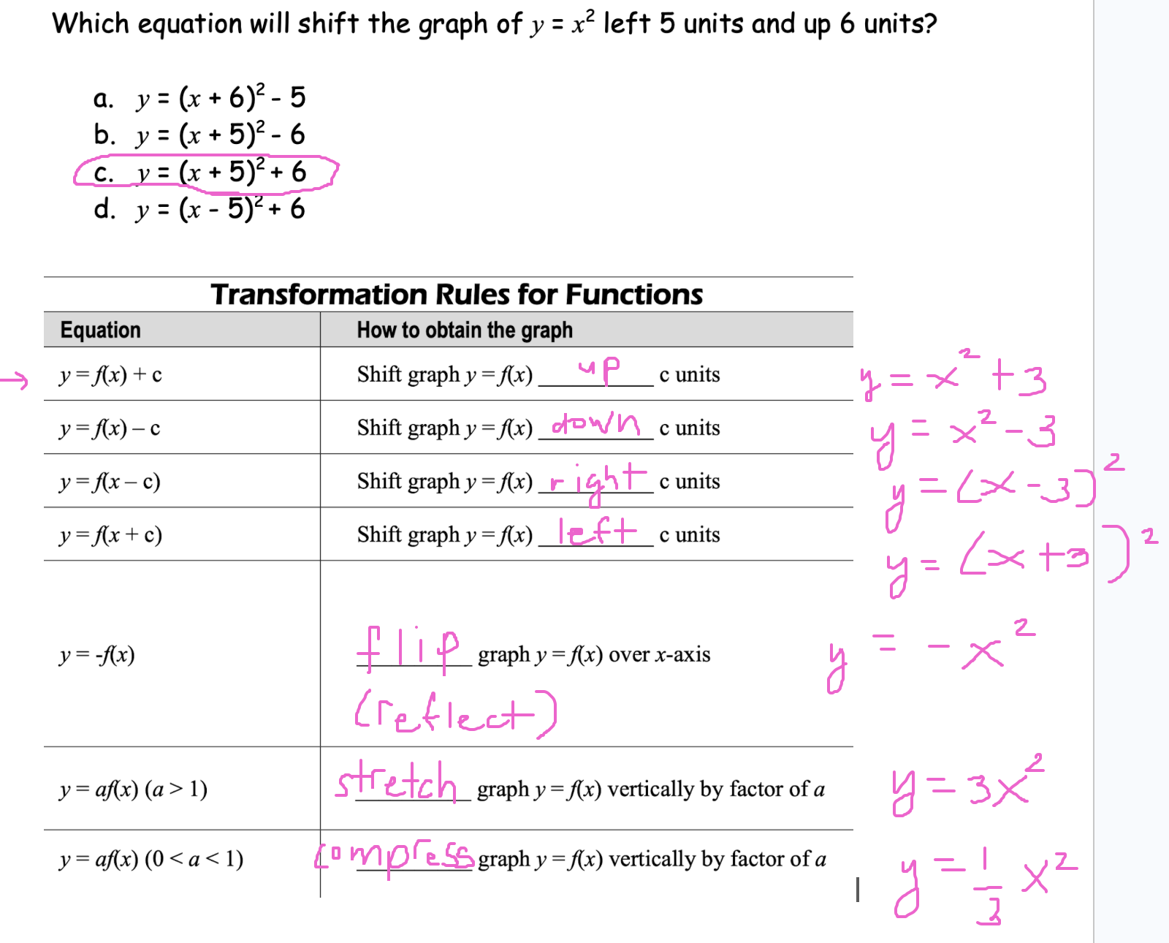

Example
a. Write the equation that shifts the graph of $f(x)=\sqrt{x}$ right 1 unit. Graph your equation.
b. Write the equation that shifts the parent graph upward 3 units. Graph your equation.

a) $y=\sqrt{x-1}$
b) $y=\sqrt{x}+3$

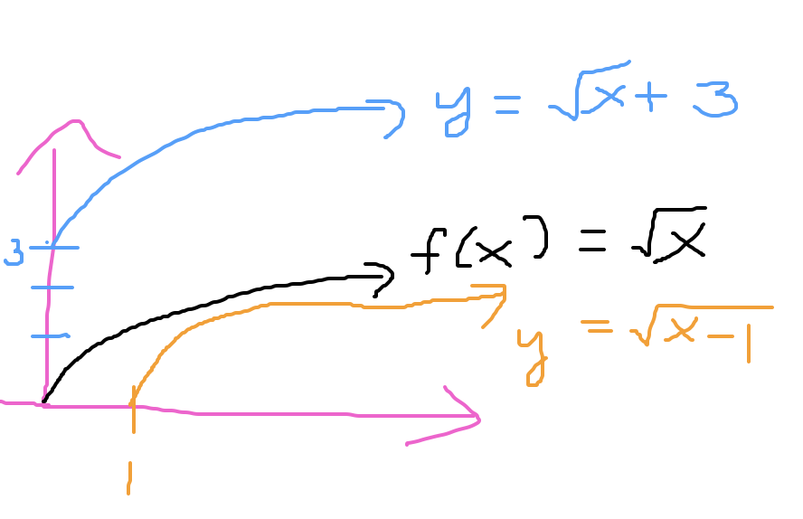

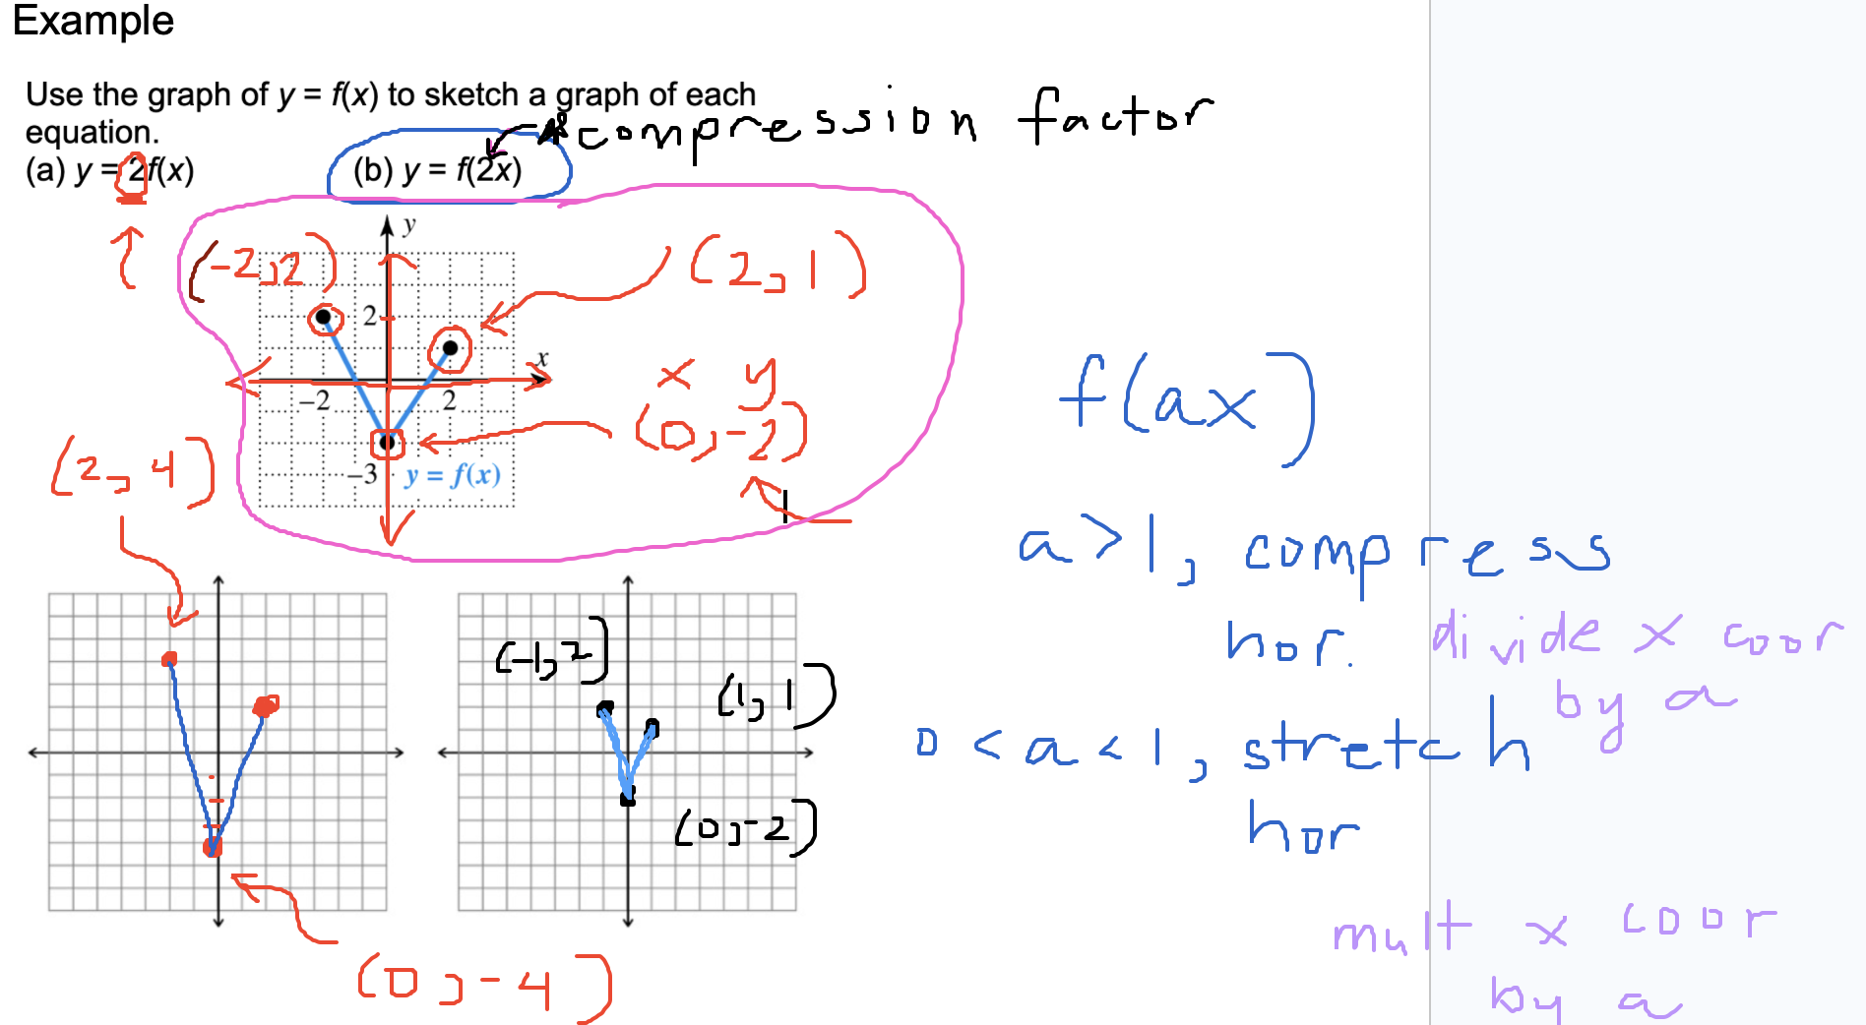

Example

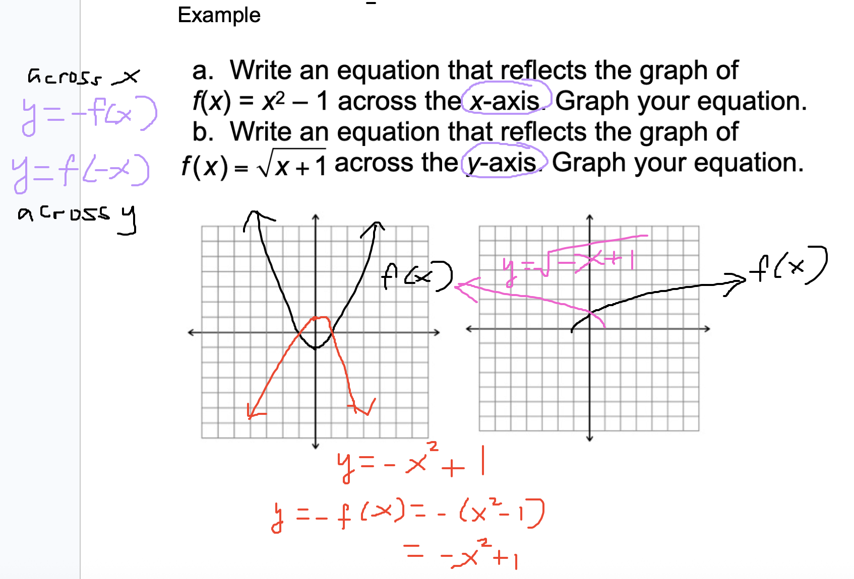

Example
